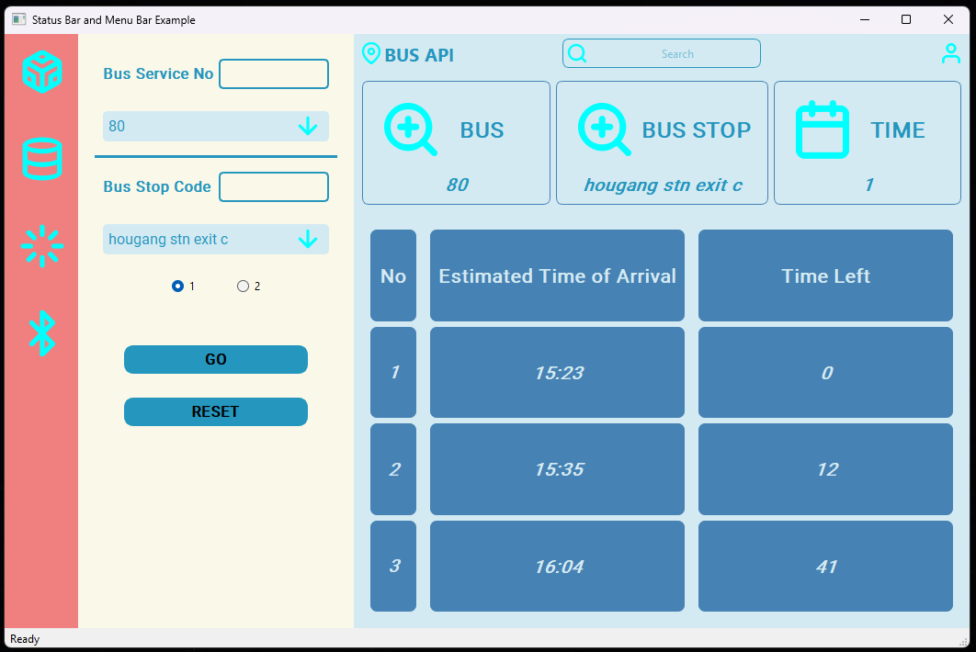

*Image 1*

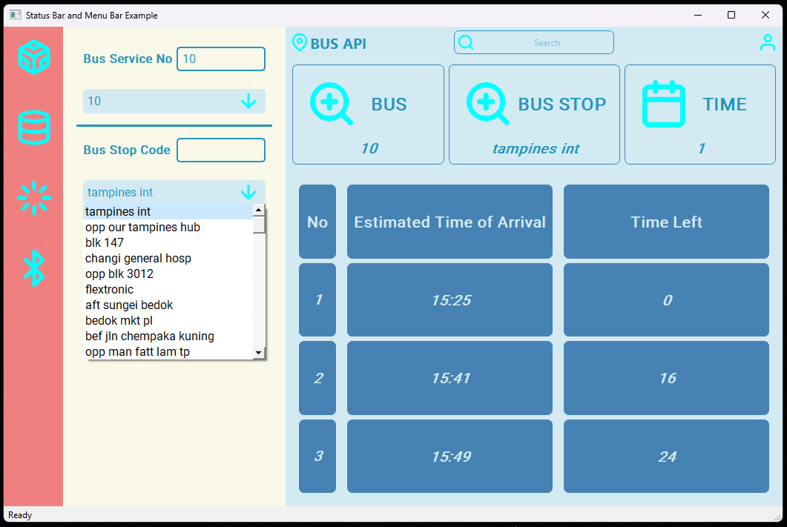

*Image 2*

There are total of 4 pages in this software application, and the above image is the main page. The main page requires bus service no and the corresponding bus station name input to get the estimated time arrival of requested bus service no and station name. the input can do through key in the bus service no and bus stop code in the left side textbox, or search the value from the combo box. For new request, reset button should be clicked to reset to the initial value and repeat the steps again.

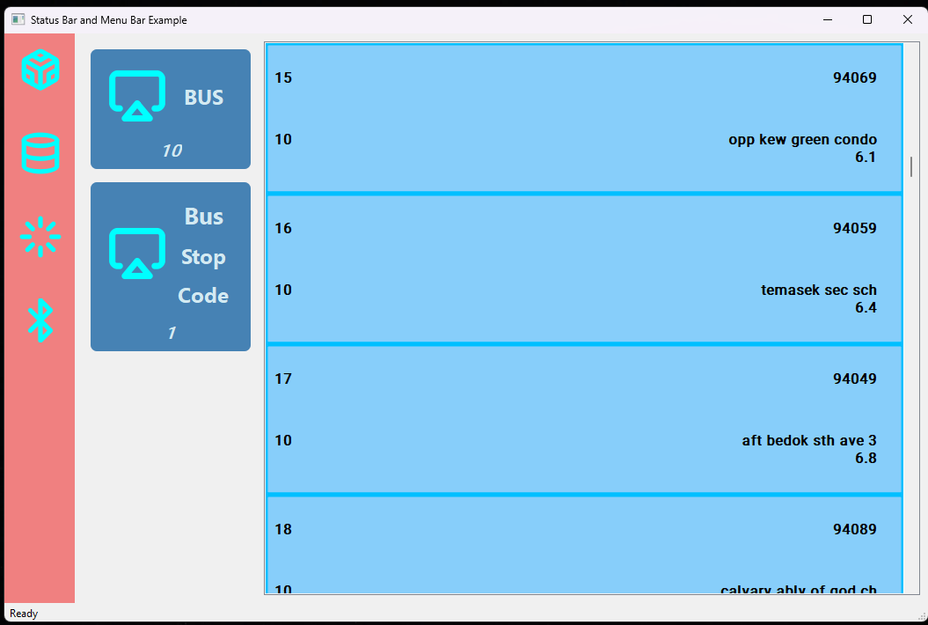

*Image 3*

*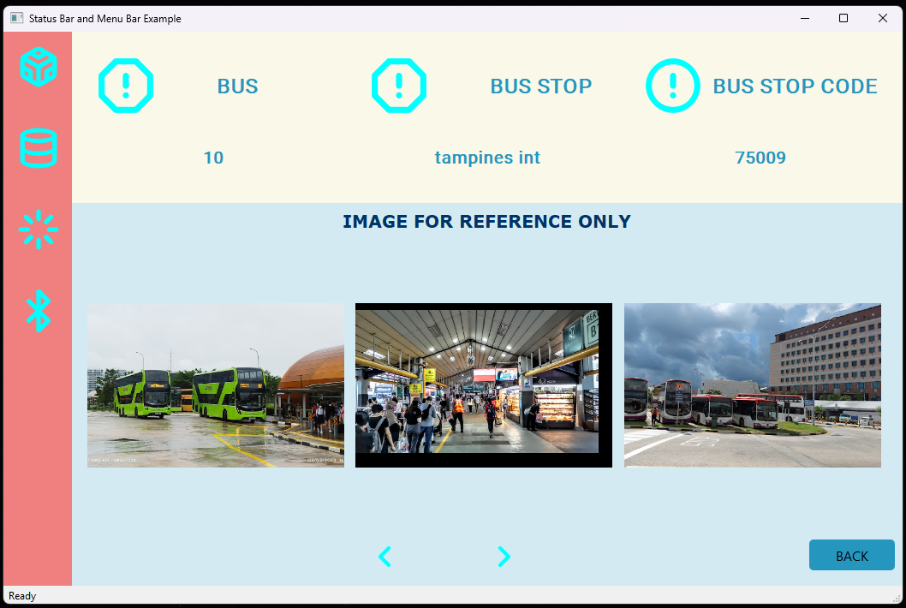*

*Image 4*

The image 3 is the second page and it is directed through the database icon from left bar. This page shows all bus stops for bus service no. 10 and first direction in the list view. For example, to check what bus stop surroundings look like for 17th bus stop which is aft Bedok sth ave 3 (94049), the image for reference can get by clicking the 17th list item and it will direct to the third page shown in image 4. The page 4 left and right arrow button can direct the image reference to 16th and 18th bus stop and more.

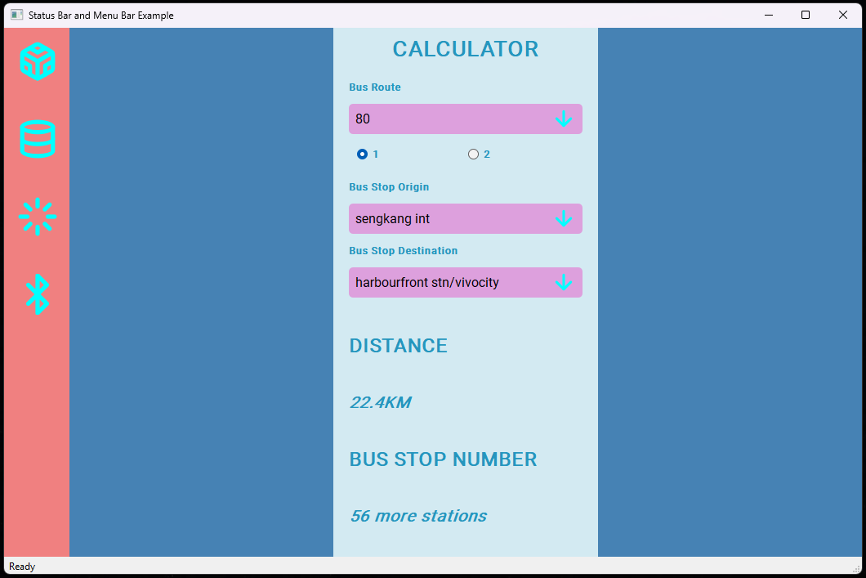

*Image 5*

The last page is the calculator to get the total distance (km) and bus stop no to reach between two bus station for a given bus service no. The image 5 is the example that bus service no. 80 will take 22.4km and 56 more bus stations to reach harbourfront station/vivocity from Sengkang interchange.